- eMind Academy invites Abacus Learning Students from various centres across the country eligible to participate in this open competition.
- It allows the student to Compete at a Common Platform (National Level), to develop a healthy competitive spirit amongst the students while giving them an opportunity to showcase their talent in the field of Abacus based Mental Arithmetic program.
- We cordially invite you to participate in this event & explore your kid's Arithmetical Calculation Skills.
- Trophies, Certificates, and Gifts will be awarded to Champion and participants for each Level.

Dear Participants / Students,

We are glad to announce the eMind Academy National Level Abacus & Mental Arithmetic Competition - 2020 (Open to all) as per the details given below: The students have to register their willingness by sending the Application as per the procedure given below:
Subject: eMind Academy National Level Abacus & Mental Arithmetic Competition - 2020 (Open to All) Date & Time of Competition: 11 – 01 - 2020 (Saturday) 10. 00 A M to 11.00 A M
Prize Distribution: 11 – 01 - 2020 (Saturday) 4. 00 P M to 6. 00 P M
Venue: Palakkad.
Participation fee for Competition: Rs. 800 /- (Eight Hundred only) per student includes snacks and lunch for Franchisees, participants and trainers accompanying kids.
Download model question paper through: Request
Last date for receipt of Applications: 15.12.2019
Important Announcement: The student participating in the Competition is registered only for the last completed level and not a lower level.
Age Limit: Minimum 5 Years and there is NO maximum age limit.
Objectives: The Competition aims at its efforts:
1. To give chance for each student to compete at the National level.
2. To promote and advocate the learning of Abacus and Mental Arithmetic.
3. To elevate the standard of performance of learners of Abacus and Mental Arithmetic.
4. To foster a closer relationship between the Franchisees, Abacus tutors and students of various centres.
5. To certify one’s capability in Abacus or Mental Arithmetic.
6. To cultivate the habit of attending objective type question paper in their future Academic and Competitive Exams.
2. Administrative Details: Competition: 11-01-2020 @ 10.00 PM. Saturday
Venue: Palakkad.
Prize Distribution: 11-01-2020 @ 4.00 PM. Saturday the same venue
6. Eligibility: Students can participate in the competition for any completed level.
a) The competition is open to all students (other companies / private abacus training centres) only as per the eligibility criteria and who are undergoing coaching in any Franchise / School Centre of any state in India.
b) A student can participate for only one level and that too for the last completed level only. Students / participants have to declare in the Application form by individually signing that the student is appearing for the last completed level only
7. Prizes:
a. Trophies along with certificate will be awarded to Champion of Champions, Winners, Champion, 1 st Runner up, 2nd Runner up for each level, by the Guest on the stage itself.
b. 1st and 2nd Runner-ups for each level will be based on the marks scored by participants
c. Certificate of Participation will be issued to all participants
d. Competition Fee: All applications (attached Excel sheet) together with the competition fees Rs. 800 should be sent to Head Office on or before 15.12.2019
9. General Rules:
a. Submission of Applications after the deadlines will not be accepted.
b. Usage of Abacus is optional – (With or without Abacus tool). All students must bring the Hall ticket and pen/ pencil/s to the competition hall.
c. All students should report at the designated time on the day of the competition.

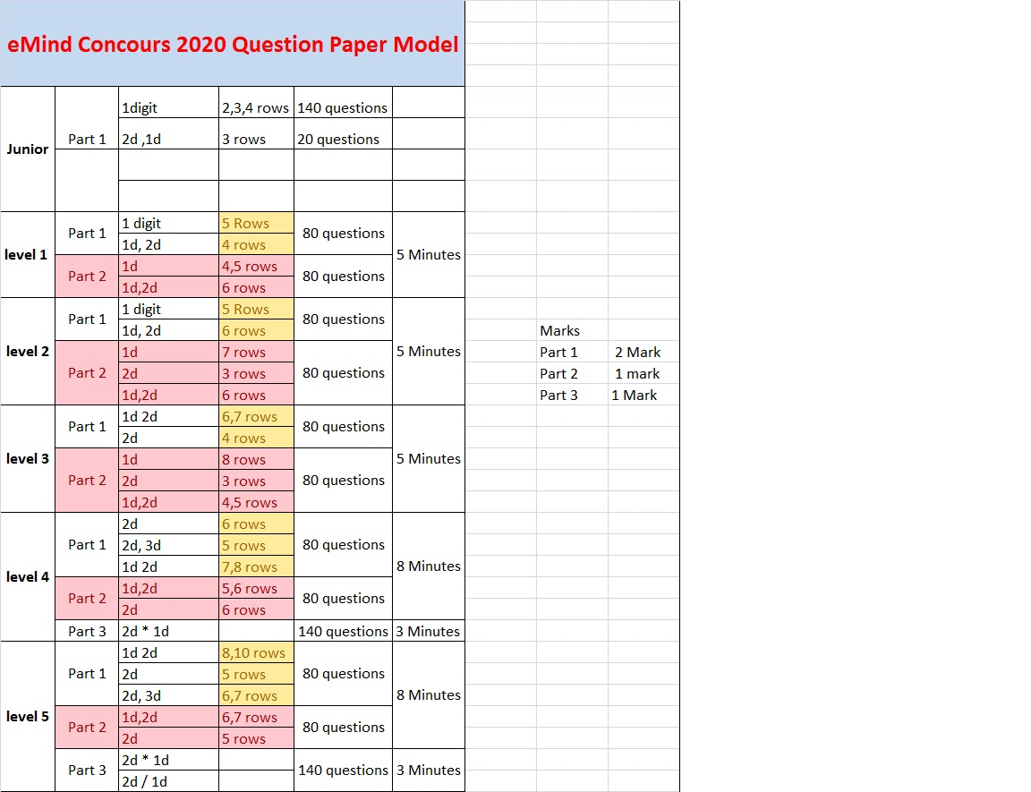
QP Model for each level (Format may change No of Rows and digits will remain the same)
